Eel River NATRC Ride
Come enjoy the beauty of the Mendocino hills,
with amazing scenery and eye-catching views!
A –Ride both days B-Ride Saturday B Ride Sunday for Novice
Leisure Division ride Saturday & Sunday
June 13th & 14th, 2026;
A-Open/CP/Novice; B1-Open/CP/Novice/ Leisure B2 Novice/Leisure

Our host, the Circle X Ranch in Potter Valley is a private ranch, so camp opening is limited to 9 am on Friday. Distance travelers that need to arrive Thursday must let the ride manager know by Wednesday the 11th^{th} so we can arrange to open the gate. Cell service is limited in the campground area but is available on the trails. Try to arrive no later than 3 pm on Friday out of respect for judges and workers. Please let us know if you will be late! Park in designated area, then check in with ride secretary to pick up rider packet.

. Ride Secretary: Ride Chair:
Maria Pilgrim Angie Meroshnekoff
9826 Irvine St 9800 Main St
Upper Lake, Ca 95485 Potter Valley CA
707-217-3582 707-743-9973
Wolves1961@sbcglobal.net awhitedog@aol.com

Emergency contact for the ride ONLY!: Angie Meroshnekoff 707-391-3408. Cell service on the ride weekend is very limited

The Ride is sanctioned by the NORTH AMERICAN TRAIL RIDE CONFERENCE and will be conducted under the rules as published in the 2026 NATRC Rule Book.

OPEN DIVISION is timed for a well-conditioned horse that can trot evenly on the flats and walk fast up and down slopes. Horse must be 5 years or older. The distance is 30 miles a day or 50 to 60 for the weekend at 4 - 6 mph.
COMPETITIVE PLEASURE DIVISION is for those experienced competitors who don’t want to advance to the faster pace in the Open Division nor be in competition with those in the Novice Division. Good conditioning is important for the ride. Horse must be 4 years or older. The distance is 20 miles a day or 35 to 40 for the weekend at 3.5 - 5 mph.
NOVICE DIVISION is timed at brisk and steady walk. Horses must be 4 years or older. The distance is 20 miles a day or 35- 40 for the weekend at 3.5 - 5 mph.
LEISURE DIVISION classes are Experienced, Adult and Junior. The distance is about 10 miles for the day.

Weight classes for this year have been combined, all adults in Open, CP and Novice will ride in one class per division. . Juniors are 17 years and under, no weight restrictions.

JUNIORS must wear an ASTM/SEI, Snell, or approved equal equestrian riding helmet at all times while mounted.

REGULATIONS - You are in competition from the time you present your horse for pre-ride examination on Friday (Saturday for Sunday’s Novice B) until final vet check on Sunday. LEISURE division checks in on Saturday morning and final check is Saturday afternoon. A saddle is required on the ride, but there are no restrictions on type of equipment used. At camp, horses can be trailer tied or in portable corrals that are securely fastened to the trailer. Hay or other feed is not available for purchase. Stallions must be double tied and ridden only by an adult. After 10:00 pm on Fri & Sat, all should be quiet so we can rest for the next day’s ride. Dogs must be on leash and well behaved; absolutely no loose or noisy dogs. All minors under 18 years of age must be accompanied by an adult in camp, and management strongly suggests juniors be accompanied by an adult on the trail. ABSOLUTELY NO SMOKING ON THE TRAIL. Water will be available for horses in camp; bring your own to drink. Because camp is far from stores, bring necessary food and supplies with you. There are no hookups, but toilet facilities are available. Eating together is part of the fun, plus a way to make new friends, but MEALS MUST BE RESERVED IN ADVANCE SO WE WON’T RUN OUT. If, due to extenuating circumstances, a rider finds it necessary to leave prior to announcement of awards, riders must advise both ride chairman and appropriate division judges (Rulebook Section 5-A-5, pg. 5-1).
Entry not valid without signed & dated liability waivers.

Eel River NATRC Ride
Entry Form

Name of Rider __________________________________ Phone number ( ) _____________________

Address _____________________________________City/State/Zip _________________________________

E-Mail address _______________________________________________________________

Current NATRC Member? Yes No (circle one) Expiration date of membership ____________________

Name of Horse ____________________________________________________________________________

Color _________________________ Age ___________ Height _____________ Weight ______________

Mare/Gelding/Stallion (circle one) Breed ____________________________________

Reg # (mail or bring papers for verification) ________________________________________

Name of horse owner (if different from rider): __________________________________________________

Signature of horse owner (if different from rider)________________________________________________

If Junior rider under age 13- name of riding sponsor ______________________________________________

Is this your first NATRC ride? Yes No Rulebooks are free with membership or download at www.natrc.org

CLASS/DIVISION (Check One) ENTRY FEE (includes drug fees)

Open A (Saturday & Sunday) Adult [ ] $145 Junior [ ] $75
Competitive Pleasure A (Saturday & Sunday) Adult [ ] $145 Junior [ ] $75
Novice A (Saturday & Sunday) Adult [ ] $145 Junior [ ] $75
Open B1 (Saturday) Adult [ ] $120 Junior [ ] $65
Competitive Pleasure B1 (Saturday) Adult [ ] $120 Junior [ ] $65
Novice B1 (Saturday) Adult [ ] $120 Junior [ ] $65
Novice B2 (Sunday) Adult [ ] $120 Junior [ ] $65
Leisure B1 (Saturday) Experienced [ ] $75 Adult [ ] $75 Junior [ ] $40
Leisure B2 (Sunday) Experienced [ ] $75 Adult [ ] $75 Junior [ ] $40

DISTANCE ONLY: $120 (Circle One) A: Open CP Nov / $100 B1: Open CP Nov /B2 Nov

FEES SUBMITTED WITH ENTRY
Entry fee from above $ _______________
All riders not a current competing member of NATRC, pay non-member fee: $25 _______________
Mandatory California drug fee $14 _______________
1st time rider discount (except for Leisure Division): subtract $10 -$10 _______________
Catered Dinner Saturday night (not sure what but good!!) # of dinners ____ $25 _______________
TOTAL ________________

Make check payable to: NATRC Region 1 c/o Maria Pilgrim, 9826 Irvine St., Upper Lake Ca 95485

In case of emergency during competition, please notify:

Name: ______________________________________________________________

Phone: (_____)___________________________
NORTH AMERICAN  TRAIL RIDE CONFERENCE  www.natrc.org, natrc@natrc.org, 402-806-8708 | 

RIDER LIABILITY WAIVER
The following must be signed and dated for entry to be valid:

"I WISH to enter and participate in the _____Eel River______________________________ Competitive Trail Ride, to be held at _____Potter Valley, CA______________________ on __June 13th & 14th 2026___ ("I HAVE READ the rules, conditions, and regulations of the event and will comply with them. I AGREE to abide by the rules of the North American Trail Ride Conference and the aforementioned ride. I UNDERSTAND that competitive riding is a high risk activity, which involves being in remote areas for extended periods of time, far from communications, transportation, and medical facilities; that these areas have many natural and/or man made hazards which ride management cannot anticipate, identify, modify, or eliminate; that horses can be excitable, difficult to control and unpredictable; that personal belongings can be damaged, lost, or stolen, and that accidents can happen to anyone at any time.
I AGREE to assume all risks associated with my participation in this activity, and I accept full responsibility for myself and the animal I am riding. As a condition precedent to my being allowed to participate in this activity, I agree that I WILL NOT SUE OR BRING ANY CLAIM AGAINST THE NORTH AMERICAN TRAIL RIDE CONFERENCE, ITS DIRECTORS AND/OR OFFICERS, RIDE MANAGEMENT, RIDE PERSONNEL, VOLUNTEERS, PROPERTY OWNERS WHERE EVENT TAKES PLACE, AND/OR ANY OTHER INDIVIDUAL MEMBERS THEREOF, (HEREAFTER REFERRED TO AS “THE RELEASED PARTIES”) FOR ANY INJURY, ACCIDENT, DEATH AND/OR LOSS OF ANY KIND WHICH ARISES OUT OF THIS EVENT, AND WILL INDEMNIFY AND HOLD HARMLESS THE RELEASED PARTIES FROM ALL LIABILITY FOR SUCH INJURY, ACCIDENT, DEATH OR LOSS, EVEN IF SUCH INJURY, ACCIDENT, DEATH AND/OR LOSS ARISES FROM THE ALLEGED NEGLIGENCE OF THE RELEASED PARTIES. I FURTHER ACKNOWLEDGE THAT I HAVE READ AND UNDERSTAND THIS STATE’S EQUINE ACTIVITY LIABILITY ACT WARNING (IF APPLICABLE), A COPY OF WHICH IS ATTACHED HERETO AND INCORPORATED BY REFERENCE HEREIN. I HEREBY CERTIFY THAT MY HORSE IS NOT UNDER THE INFLUENCE OF MEDICATION AND WILL NOT BE TREATED WITH OR GIVEN ANY MEDICATION PROHIBITED BY NATRCTM RULES. I HEREBY GIVE PERMISSION TO THE NORTH AMERICAN TRAIL RIDE CONFERENCE OR THEIR DULY APPOINTED AGENT, TO TAKE ANY APPROPRIATE ACTION DEEMED NECESSARY TO CHECK FOR POSSIBLE ADMINISTRATION OF DRUGS TO MY HORSE."
Junior riders must wear an ASTM/SEI, Snell, or approved equal equestrian riding helmet at all times while mounted.
To the extent any dispute arises out of this agreement, the parties agree to submit said dispute to binding arbitration before a neutral arbitrator mutually selected by the parties, said arbitration to be conducted in accordance with the Rules of the American Arbitration Association. All such arbitrations shall be held in the county or district where NATRC National headquarters are located. If the prevailing party, NATRC shall be allowed to recover all costs and expenses incurred, including attorney’s fees and costs. “MY SIGNATURE BELOW CONSTITUTES ACCEPTANCE OF THE ABOVE TERMS AND CONDITIONS. I HAVE READ AND UNDERSTOOD THIS LIABILITY RELEASE AND BINDING ARBITRATION CLAUSE.”

Name of Rider/Participant (print) Signature Rider/Participant Date

Signature of Parent(s) or Legal Guardian(s) who consent to Junior Rider/participant working and/or riding in Competition. Signature of at least one parent or legal guardian is required while the signature of both parents or legal guardians is preferred.

Parent/Legal Guardian 1 (print) Signature of Parent/Legal Guardian 1 Date

Parent/Legal Guardian 2 (print) Signature of Parent/Legal Guardian 2 Date

Name of Junior Rider/ Participant Birthdate

Name of adult responsible for Junior Phone

Owner of Equine, if different from rider (print) Signature of the equine owner Phone

LIABILITY WAIVER
CALIFORNIA

I acknowledge that I have noted the following WARNING which will also be posted at the ride sign-in location:
“WARNING: Equine activities are inherently dangerous. You are assuming the risk of injury or death by participating in this activity. NATRC will not be liable for the injury to or death of a volunteer or participant in this activity.”

I also acknowledge the following:

I waive all liability of NATRC and its affiliates for any loss, injury or damage which arises from the “inherent risks” of an equine activity.

“Inherent risks of an equine activity” also means a danger or condition that is an integral part of an equine activity, including, but not limited to, any of the following:

(a) Propensity of an equine to behave in ways that may result in injury, death, or loss to persons on or around the equine;

(b) The unpredictability of an equine’s reaction to sounds, sudden movement, unfamiliar objects, person, or other animals;

(c) Hazards, including, but not limited to, surface or subsurface conditions;

(d) A collision with another equine, another animal, a person, or an object;

- The potential of an equine activity participant to act in a negligent manner that may contribute to injury, death, or loss to the person of the participant or to other persons, including but not limited to, failing to maintain control over an equine or failing to act within the ability of the participant.

_________________________________________________________________________________________________
Name of Rider/Participant (print) Signature of Rider/Participant Date

Signature of Parent(s) or Legal Guardian(s) who consent to Junior Rider/participant working and/or riding in Competition. Signature of at least one parent or legal guardian is required while the signature of both parents or legal guardians is preferred.

________________________________________________________________________________________________
Parent/Legal Guardian 1 (print) Signature of Parent/Legal Guardian 1 Date

________________________________________________________________________________________________
Parent/Legal Guardian 2 (print) Signature of Parent/Legal Guardian 2 Date

__________________________________________________________________________________________________________
Name of Junior Rider/ Participant Birthdate

_________________________________________________________________________________________________
Name of adult responsible for Junior Phone

________________________________________________________________________________________________
Owner of Equine, if different from rider (print) Signature of the equine owner Phone

Directions: (See below for maps)
From the east, take Highway 20 West from Williams towards US 101 about 72 miles; watch for signs for the Potter Valley turnoff. Just as a passing lane begins, get in the right lane and into the right turn pocket. You are now on Potter Valley Rd.
From Hwy 101, take the Hwy 20 East turnoff (towards Lake County). Go about 4 ½ miles, watch for signs to Potter Valley, turn left onto Potter Valley Rd.
Go about 6 miles on Potter Valley Rd. After the road makes a hard left turn, make a right onto Eel River Rd (right turn at Hoppers Saloon). Drive 4 miles on Eel River Rd to the Cutoff. Stay left at the Cutoff and a right at the bottom of the hill. Cross the Eel River Bridge and turn left onto Ridgeway Highway (this is a 2 lane county road, not a highway). Go 4 miles to the ranch gate, camp is ¼ mile past the gate on the left
GPS address 22500 Ridgeway Hwy, Potter Valley, CA. The drive takes about 40 minutes from the Hwy 20/ Potter Valley Rd turn
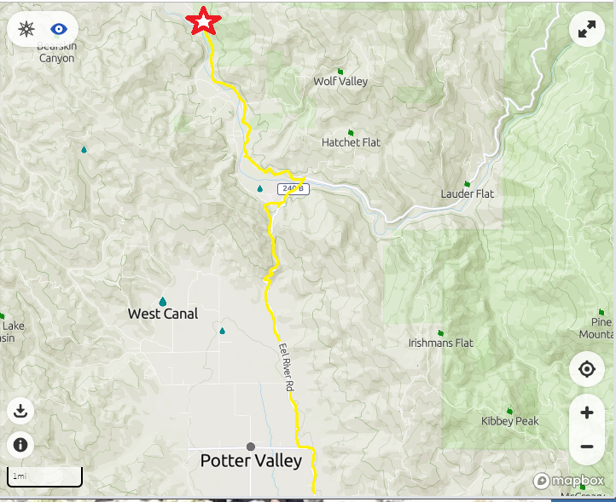

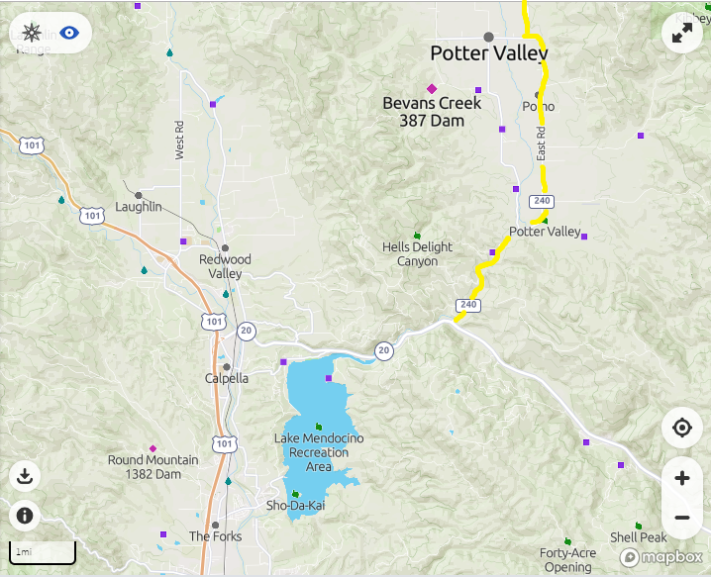

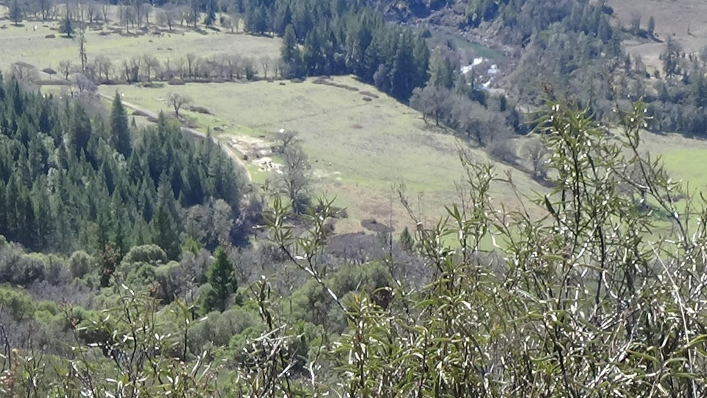

RAFFLE!!
Lots of good stuff

Fun facts about the Circle X Ranch:
The ranch has been in the Todd family since the early 50’s. It covers nearly 3,000 acres and is bordered by the Eel River one side and the Mendocino National Forest on the other. The ride will cross the river and into the 4000 acre Eddie Ranch. Camp elevation is about 1500 ft and some of the ride (Open riders) reaches 3800 ft. There is a mixture of heavy pine forest and open meadows with lots of ponds on this ranch. The Warden Ranch next door is now part of the ride and covers nearly the same acres and elevation.
The campsite is a beautiful meadow and a shady tree filled picnic area with running water and portable toilets and even a tree swing!

